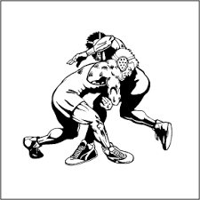
BELLMORE-JFK WRESTLING
50TH ANNIVERSARY / COACH MUNNICH CELEBRATION
FRIDAY
DECEMBER 18TH, 2015
BELLMORE-JFK
VS.
BETHPAGE
6:30 PM

