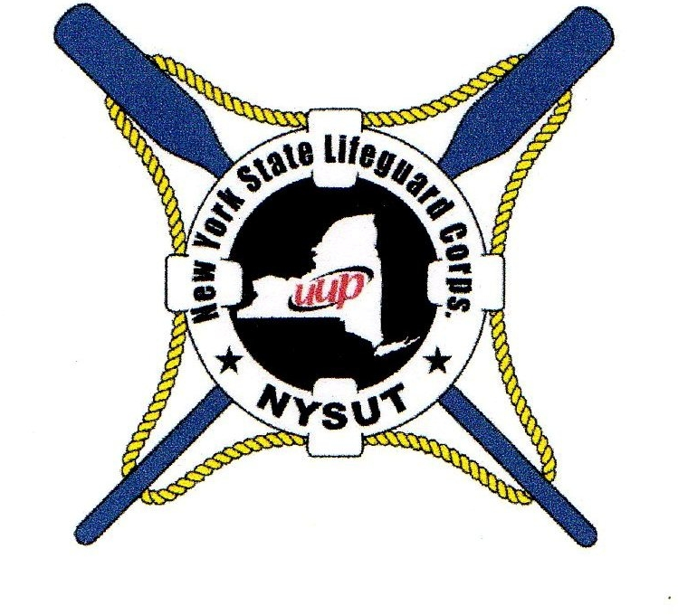

25 Deer Drive Nyslifeguards.org
Sound Beach, NY 11789 (516)551-1875
Brucemeiro@yahoo.com

President
Bruce Meirowitz
First Vice President
Thomas Donovan

Regional Executive Officer
Western Region
Matthew Hout
Southern Region
Greg Quinlin

Secretary
Robert Adler
Treasurer
John Weber

N.Y.S.U.T./A.F.T. Delegate
Joe Clerici

Regional Delegates
Allegany Park

Central New York

Department of Environmental Conservation

Finger Lakes Park

Genesee Park

Long Island
Ryan Clark
James Hammill
James Rooney

New York City Park

Niagara Frontier Park
Matthew Hout

O.M.H.D.D.
Timothy Forsyth

Palisades Interstate Park

Saratoga/Capital District

Taconic Park

Thousand Islands Park

Dear Fellow Executive Board Members and Representative Assembly Delegates,

I would like to take this opportunity to congratulate each and every one of you for being elected to the Executive Board , and the Representative Assembly of the New York State Lifeguard Corps. The positions you now hold come with the responsibility of representing our lifeguards from Montauk to Niagara and from Staten Island to the Northern Regions. We are still in our early formative years and look forward to building a future for New York State Lifeguards. We will be scheduling a Representative Assembly meeting either in late November or early December. We are currently still involved in negotiating our future contract, and hope to have some positive news to share by our next meeting. I have enclosed a copy of the 2012 – 2014 election results. There is a tie for the remaining 3 delegate seats for the Long Island Region. I plan to research the bylaws and the Election Certification Committee at UUP to formulate a solution to fill those seats. When I have received some guidance I will keep you informed.

In Solidarity

Bruce Meirowitz

